Flowchart Designs
Registration Flowchart:
Flowchart begis with a start then tells the user to input their user and password and their confirmed password, this is then checked and validated to see if the inputs are valid and the confirmed passwords are matched, if not the user is sent back to enter their email and password once again, but when it does match, its saved to to the database and they are redirected to the Login page.

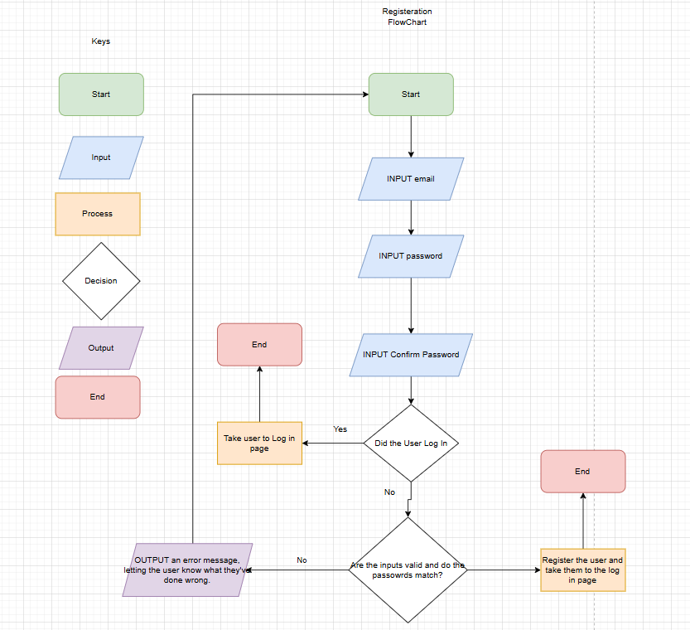
Log in Flowchart

This flowchart begins with the person putting in their email and password which has to be the same as the one you used to email, then if the user has forgotten their password, the email in which they input, a password reset email would be sent, and they would repeat the process again. If the user doesn’t have a Log in and they want to register and they’ve clicked the register button, it will redirect them back to the register page, if the user has inputted their correct details, they are then logged into the system and redirected to the homepage, however if not, a error message will popup telling you what went wrong, then redirects you back to the log in page and starts again.
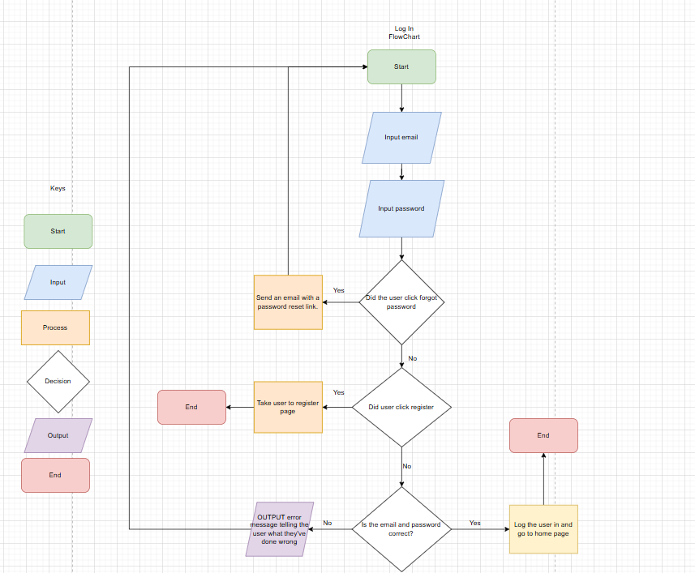
View/Amend Booking Flowchart

This flowchart begins with the system checking whether or not the user is logged in first, if not they are redirected back to the login page. Once it is confirmed that they’ve logged in, they select manage booking as the one of the options on the navigation bar. This will allow you to re-enter the booking reference you’ve used to book the room and surname that you’ve entered and finally the arrival date, once these are valid and confirmed, it will allow you to view your booking and make any amends to it or even cancel, if not you will have to restart the form all over again.
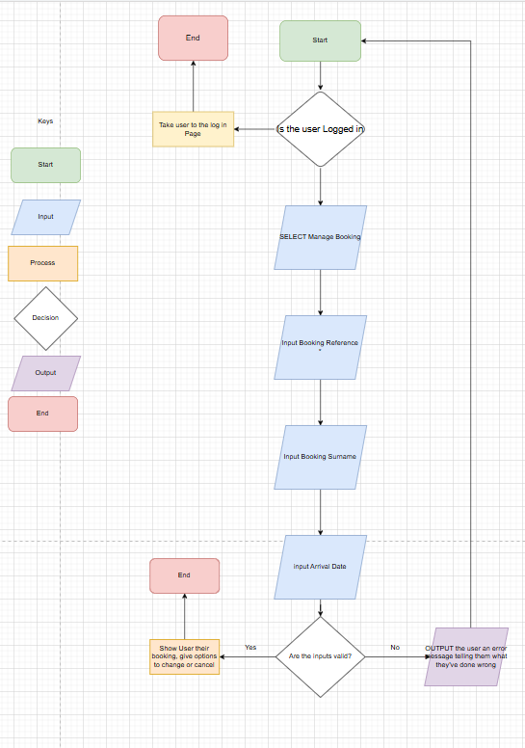

Booking
This will begin with the user entering the location of where they want to book, then the amount of guests and finally, the arrival date, then once the inputs are valid, the system outputs the available rooms of that specific location, if not you would have to restart the form again. You then input which room you want then it shows that rooms details, this shows its price, reviews and its photos aswell. Once you select Book now, you then enter a booking reference which has to be unique, and then your booking surname, and finally the arrival date. If the inputs are valid, you are then redirected to a payments page where you enter your payment details, once that’s done and paid, you are sent a receipt to your email showing you your booking reference arrival date and finally the surname (which shouldn’t be shown to anybody else).

